GitHub Actions CI Implementation Evidence
Name: Harsh Kumar
Roll No.: 202401100200149
Branch: CSE
Section: C

GitHub repository URL:
Link
https://github.com/HARSH-dev1708/github-skills-challenge

Pull Request URL
Link
https://github.com/HARSH-dev1708/github-skills-challenge/pull/1

Implementation Summary
The repository contains:
- The original Python application in src
- The original test suite in tests
- python-tests.yml
- python-coverage.yml
- Required dependency configuration in requirements.txt
- Commits containing the completed GitHub Actions implementation
The workflows are configured to run when a pull request targets the main branch.

Screenshot 1: GitHub Actions workflow list
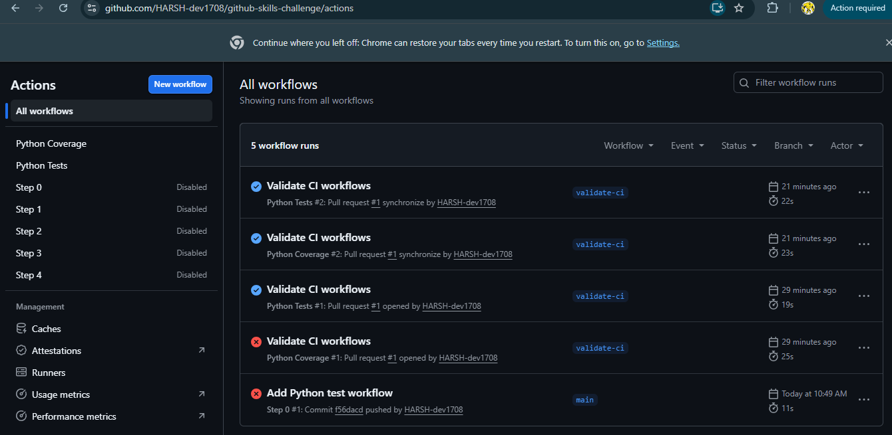

Screenshot 2: Successful Python Tests workflow
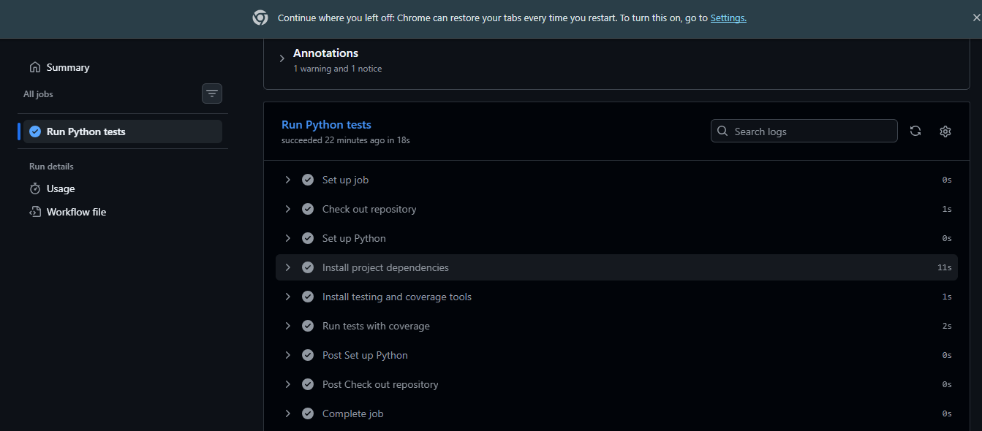

Coverage Workflow
The coverage workflow:
- Runs on pull requests targeting main
- Sets up Python 3.13
- Installs the project dependencies
- Installs pytest and pytest-cov
- Generates coverage for the src directory
- Publishes coverage information to the pull request
- Enforces a minimum coverage threshold of 50%
- Fails if coverage is below 50%
Screenshot 3: Successful coverage workflow

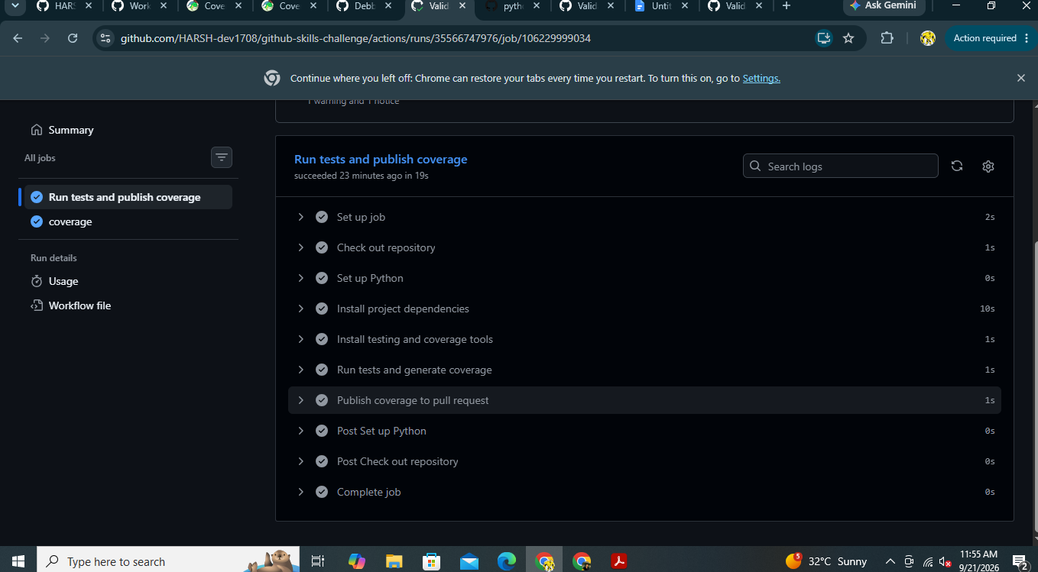
Screenshot 4: Coverage pull-request comment

